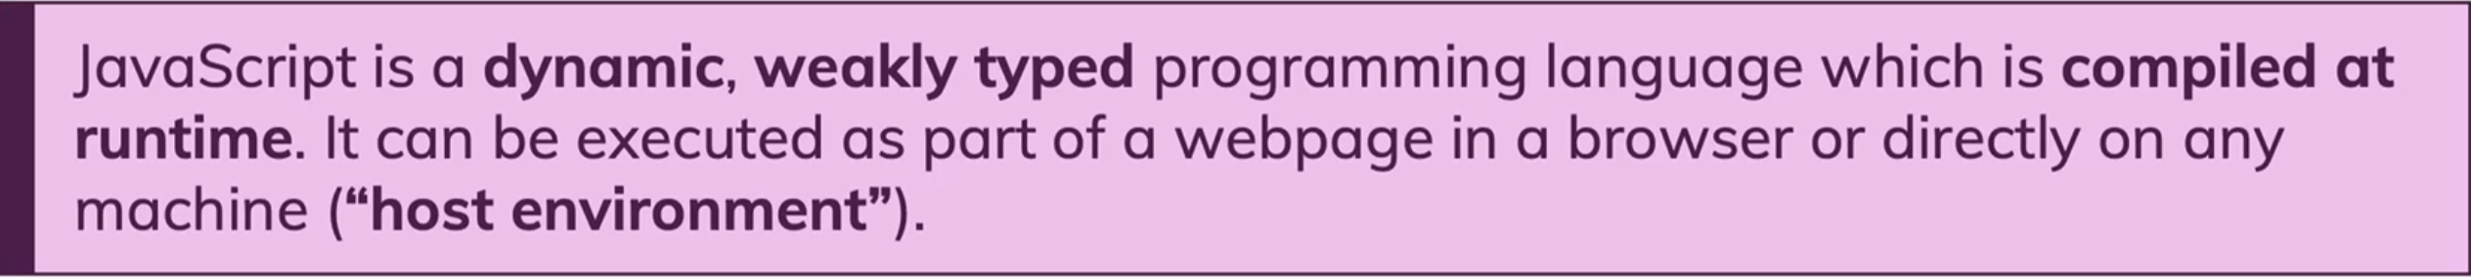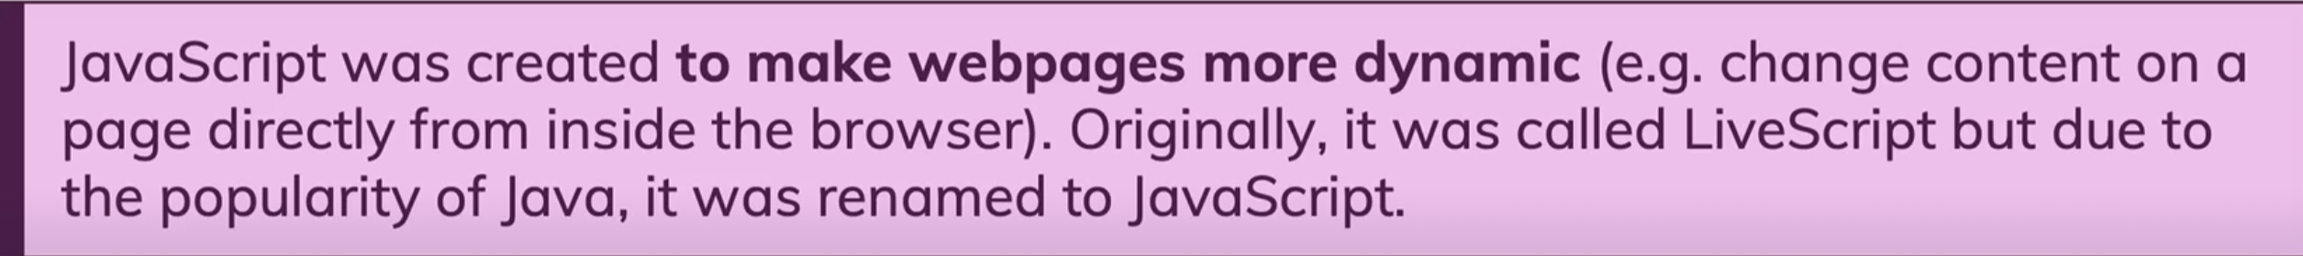

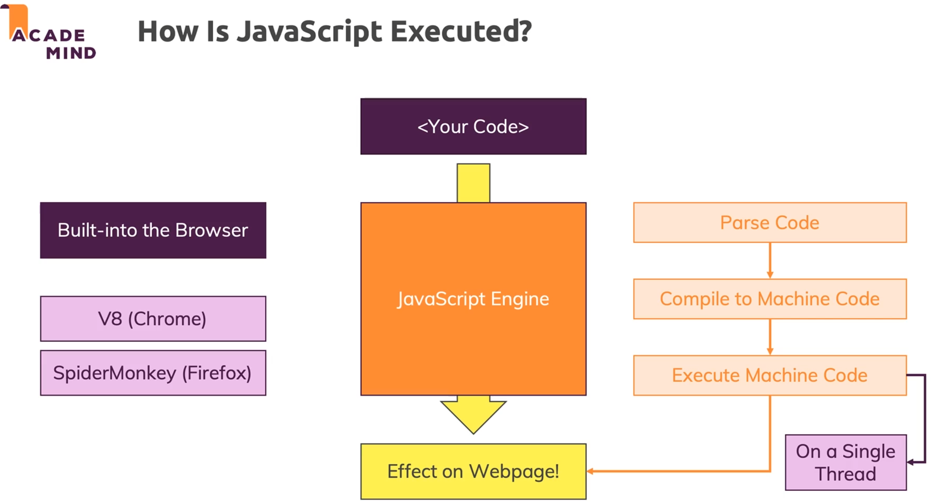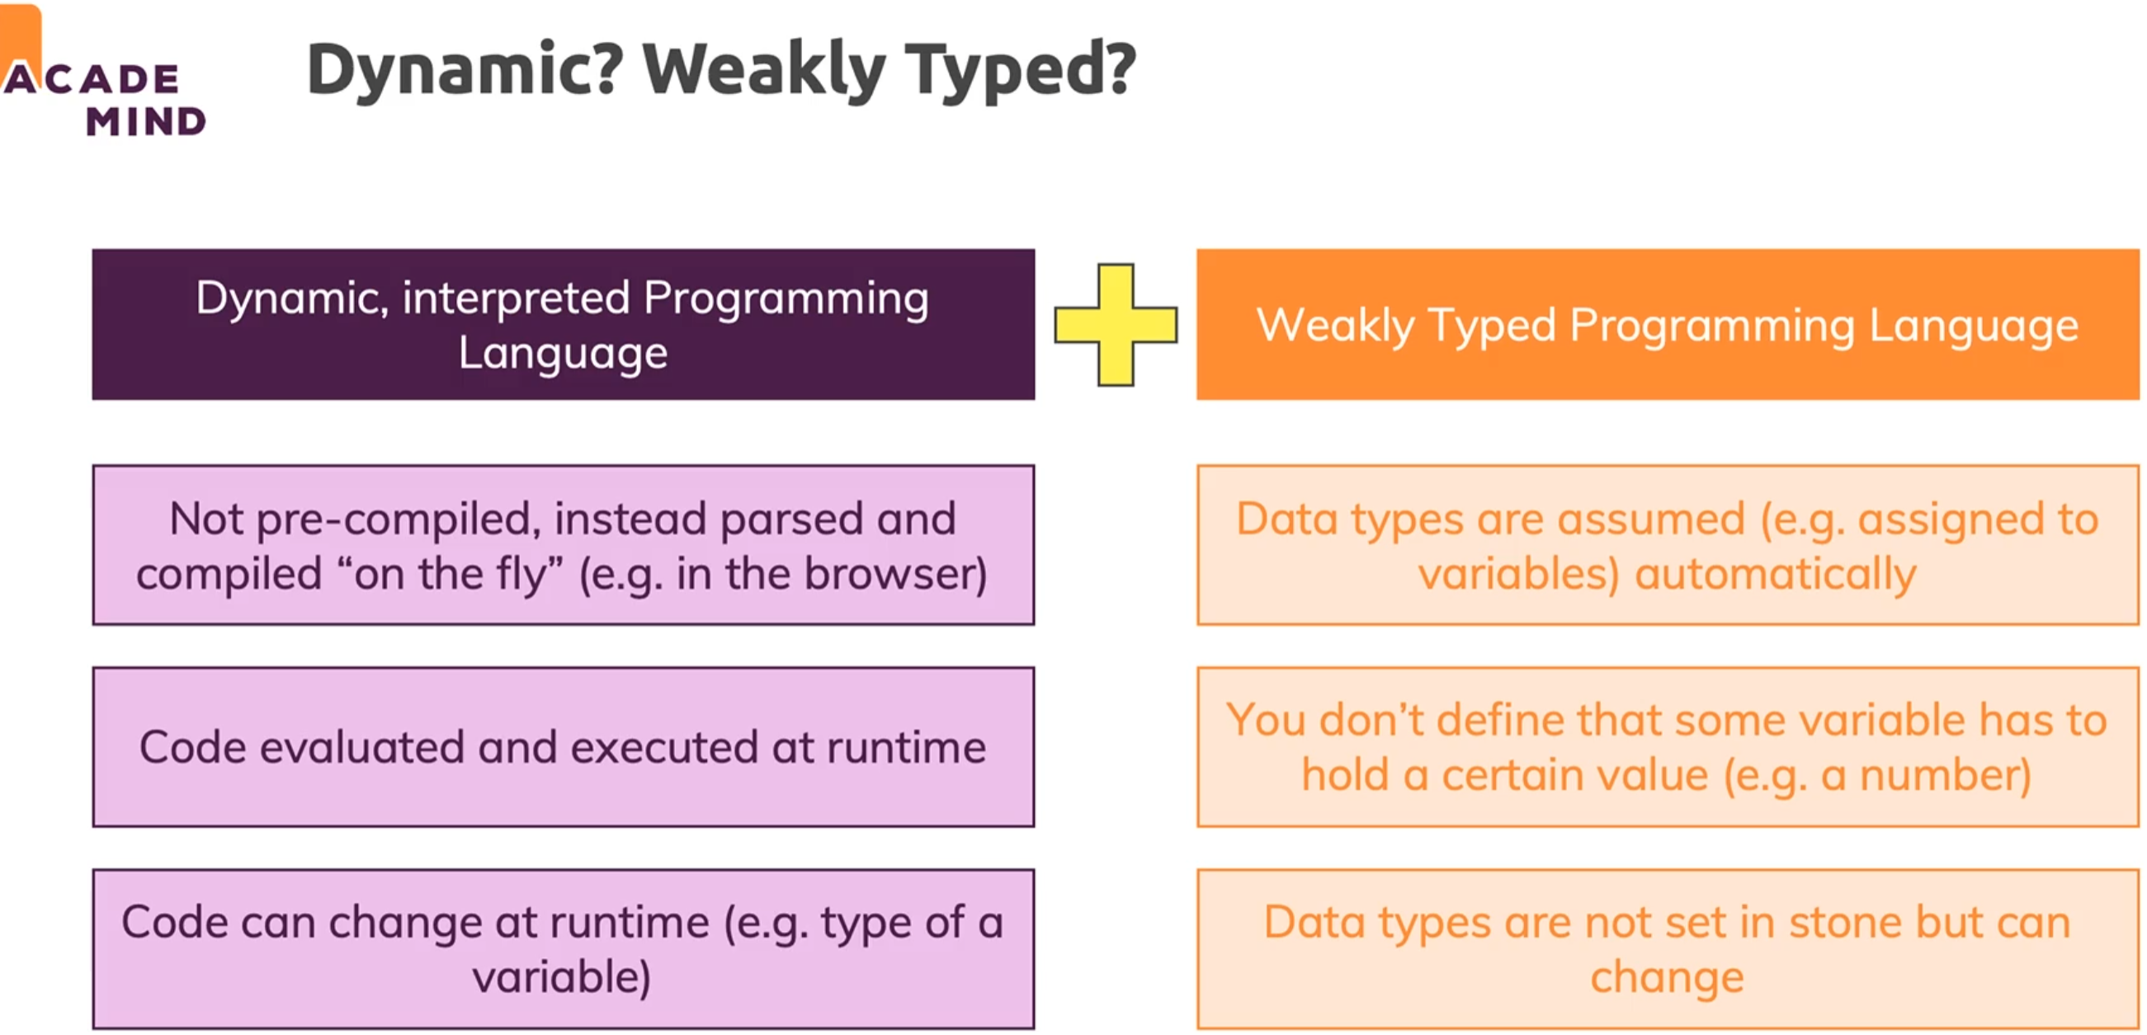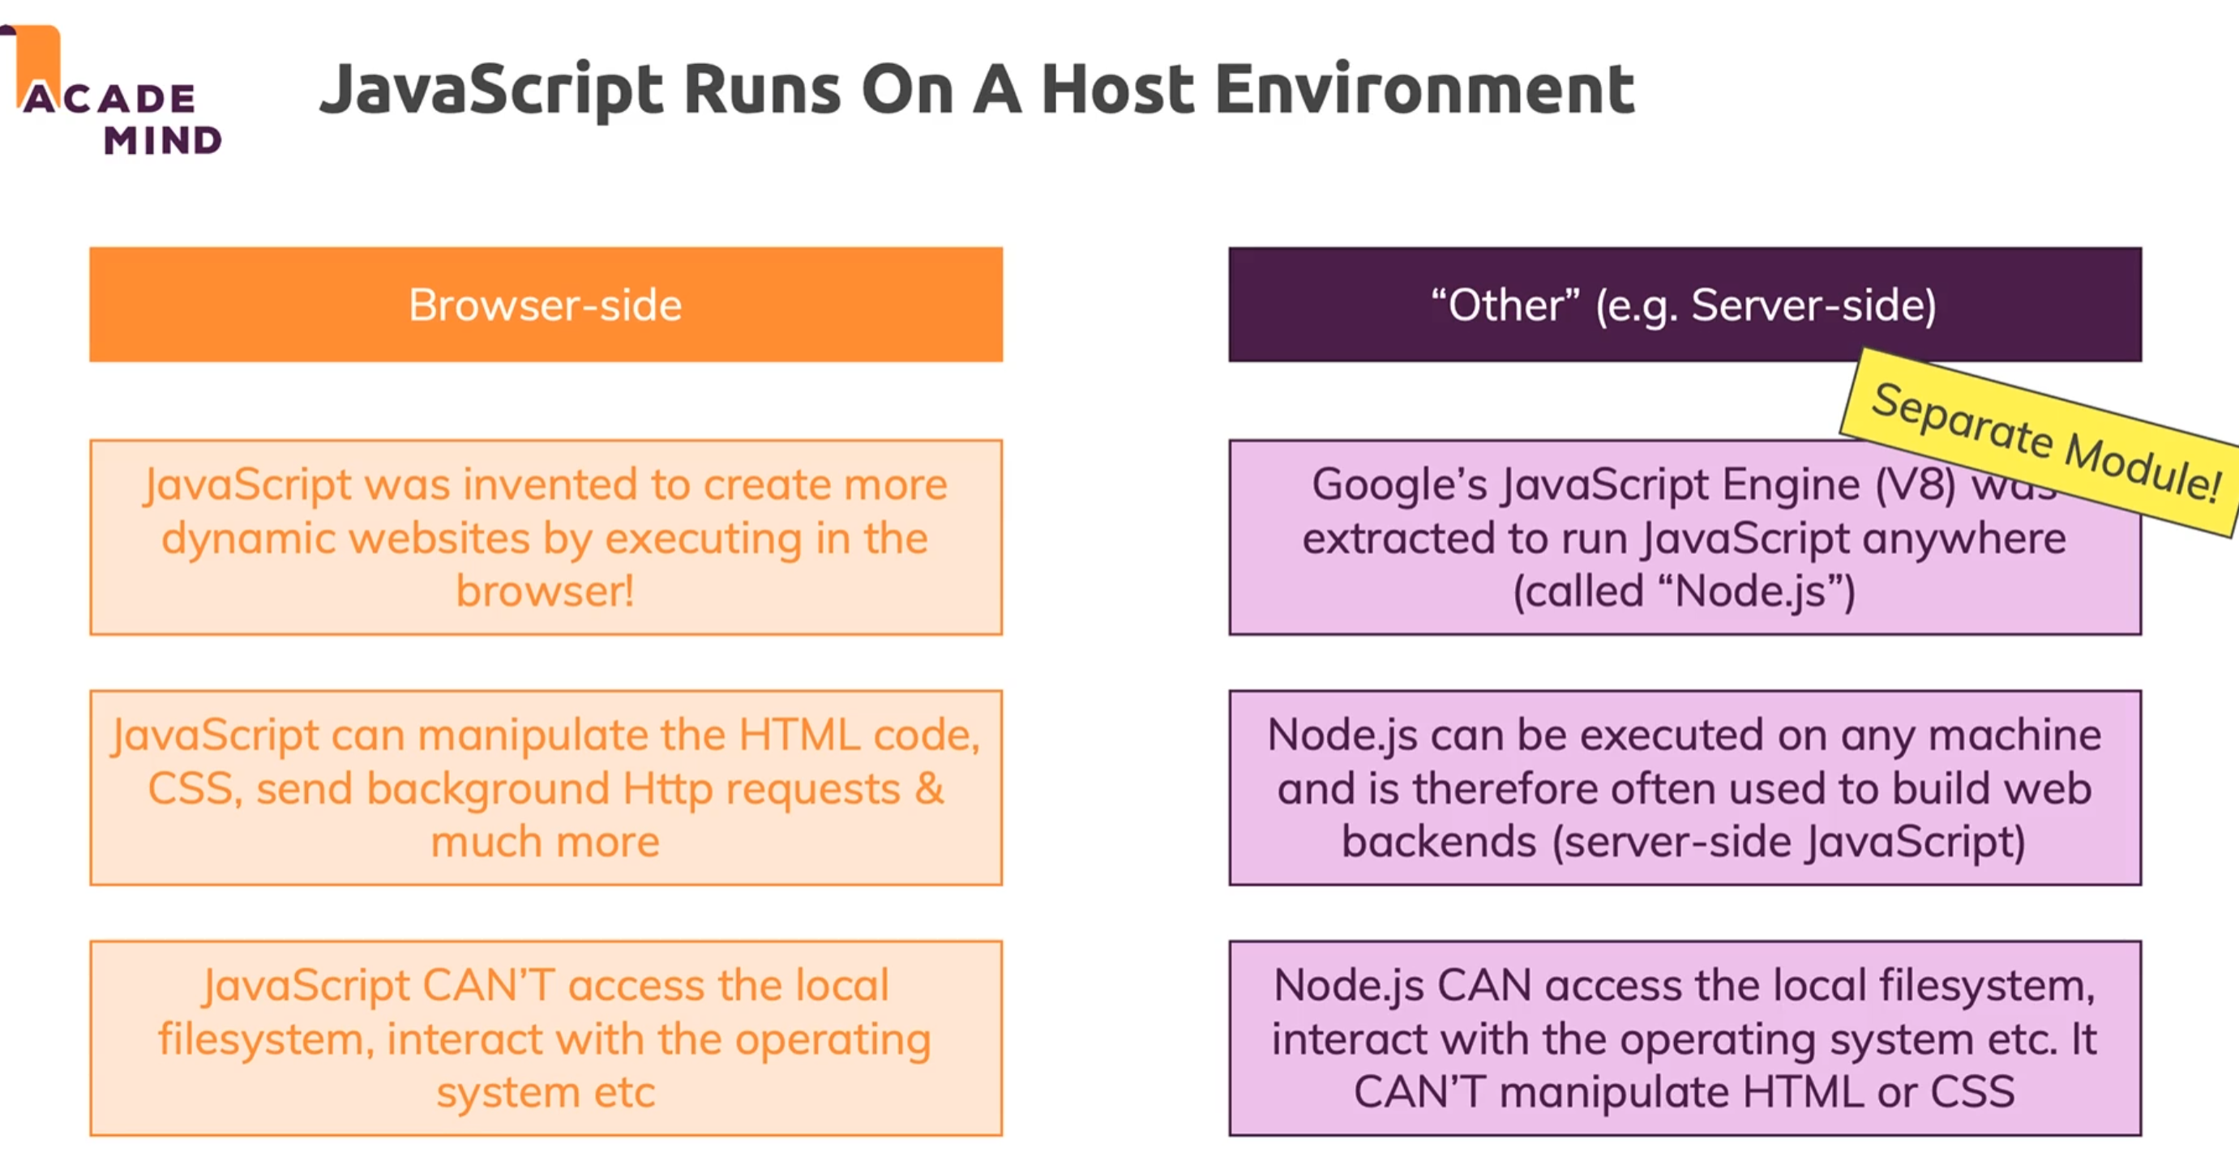

|  |
| --- |
| I m p o r t a n t ! |

Start Git for my first project in this course:  
1- CTRL + ` to go to terminal in my VS cdoe type: D: (powershell)

2- CTRL + ` to go to terminal then click + on terminal to choose bash (now type: cd /d/ ) to

go to D folder on computer.

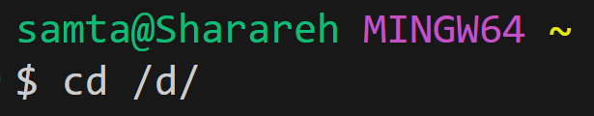

3- Type ls to see the files inside of the folder we are in now.



4- I choose the learning_2 folder inside of the D folder. I type: cd learning_2

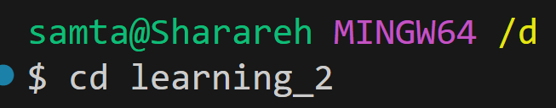

5- I type ls to see the folder inside of leaerning_2. Then I choose Academind folder. Therefore, I typed cd Academind

6- Again I choose another folder inside of it. I typed: 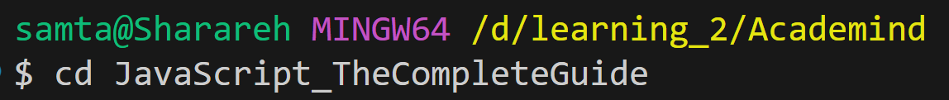

7- Now I want to initialize a new Git repository. Inside of our project directory, we initialize a new git repository: we type: git init



8- Now we create a simple JavaScript file to start our project: we type

echo “console.log(‘Hello, World!’);” > index.js



9- Now we create a README file in our project to explain what it does: we type

echo “# My JavaScript Project” > README.md



10- now as we see from the screenshot tow files has been created:  
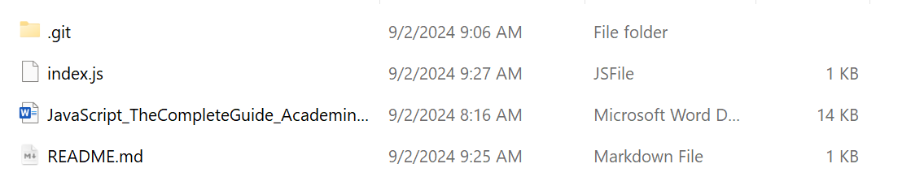

11- now we stage our files to commit. We need to add the files to stage area: we type git add . 

Notice: the space between git add . the point has distance from add ‘ . ‘ adds all files in the directory. We also can add specific files if needed.

12- Now commit our changes with a message: we type: git commit -m “our message” 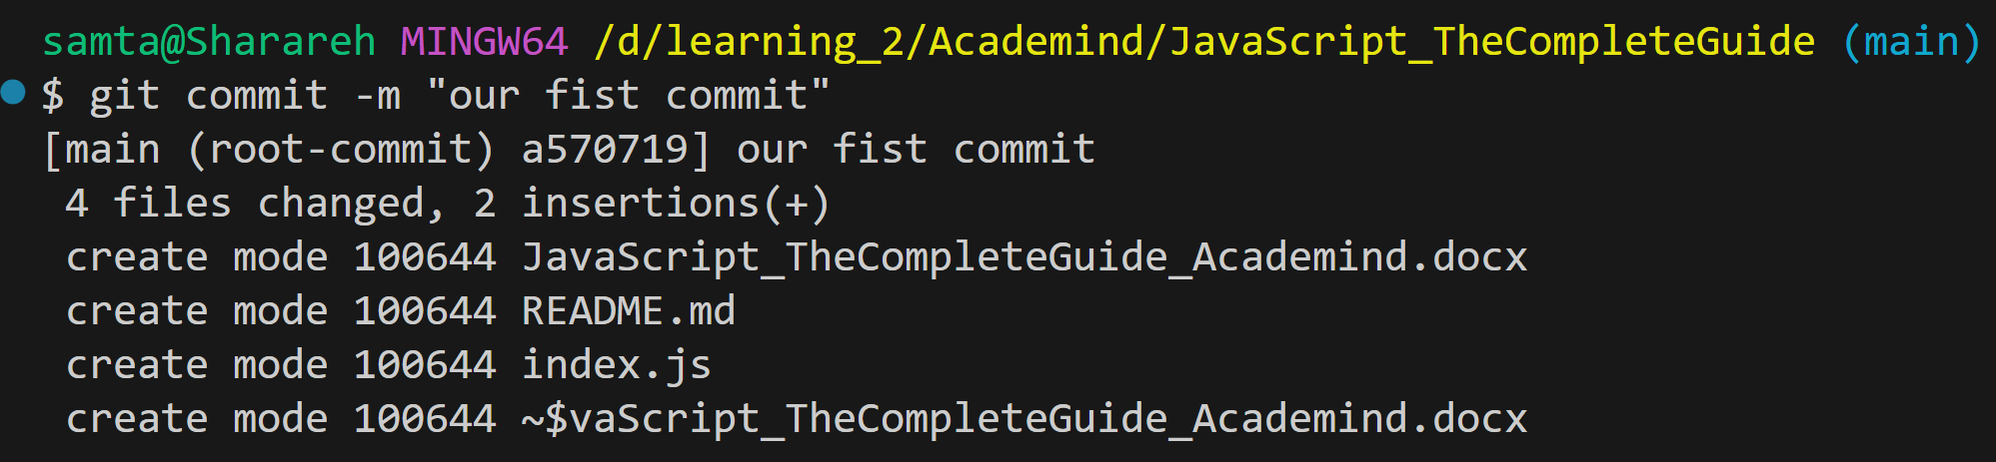

13- Now create a New Repository on GitHub:

We go to GitHub account and create a new repository. We do not initialize the repository with a README, .gitignore, or license since we already have those locally. I went to my GitHub account and I created a new repository, I named it “JavaScriptAcademind”

Then GitHub Showed me this page:  
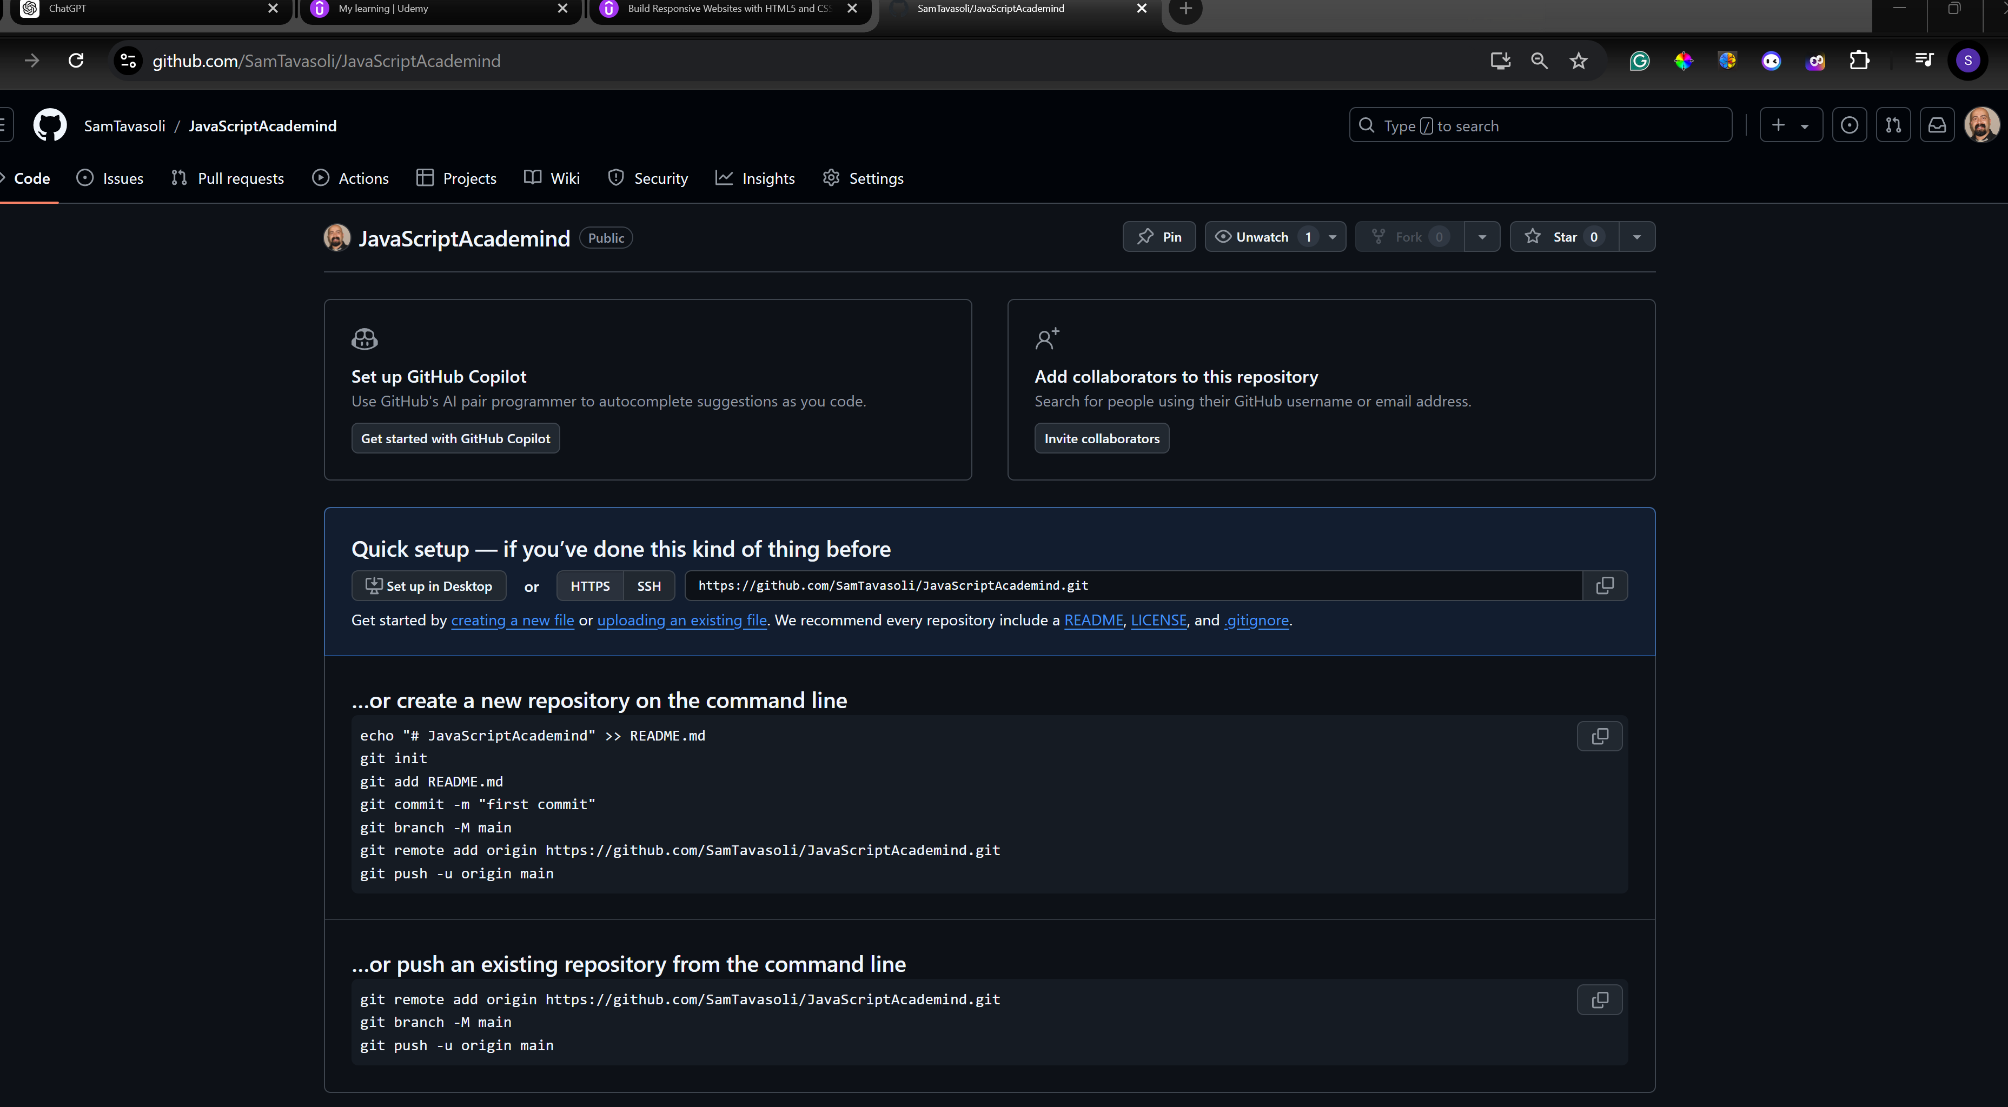

14- Now in the terminal, we can connect our local repository to the GitHub repository we just created: we see the commands in the page after creating repository in our GitHub account and we can use it.

There are two parts. One says …or create a new repository on the command line

and the other says …or push an existing repository from the command line

we use the second part since we created our repository locally: we type

git remote add origin the URL that GitHub gave it to use after we created new repository in our GitHub account.



15- Now we push our code to the GitHub repository using; git push -u origin main

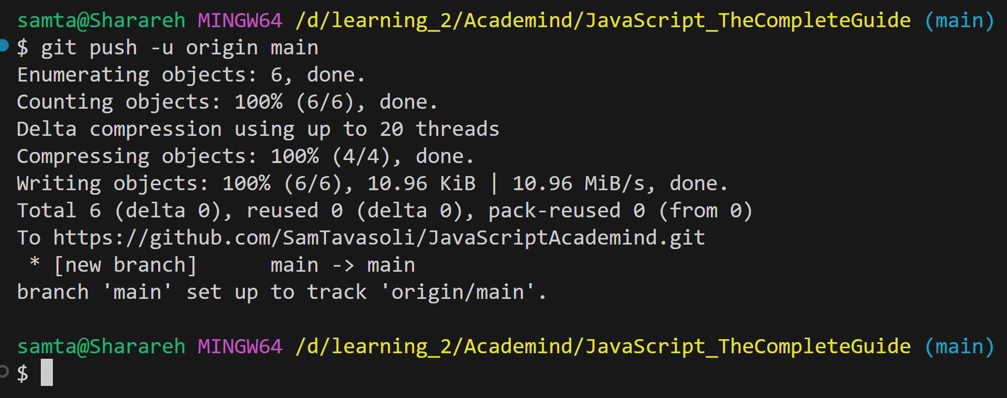

16- Now we can check our GitHub repository. We can go to our GitHub repository in our web browser, and we have to see the files there.

**Summary of our commands**:  
**1- Go to directory**

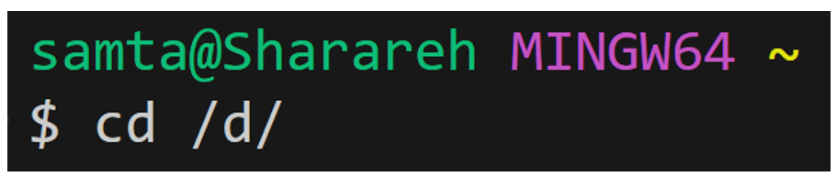

**2- Initialize the repository:**



**3- Create JavaScript file:**  


**4- Create README file:**  


5- Stage our files:  


6-Cmmit our files:



7-Link to GitHub:

8-Push our code:   
   
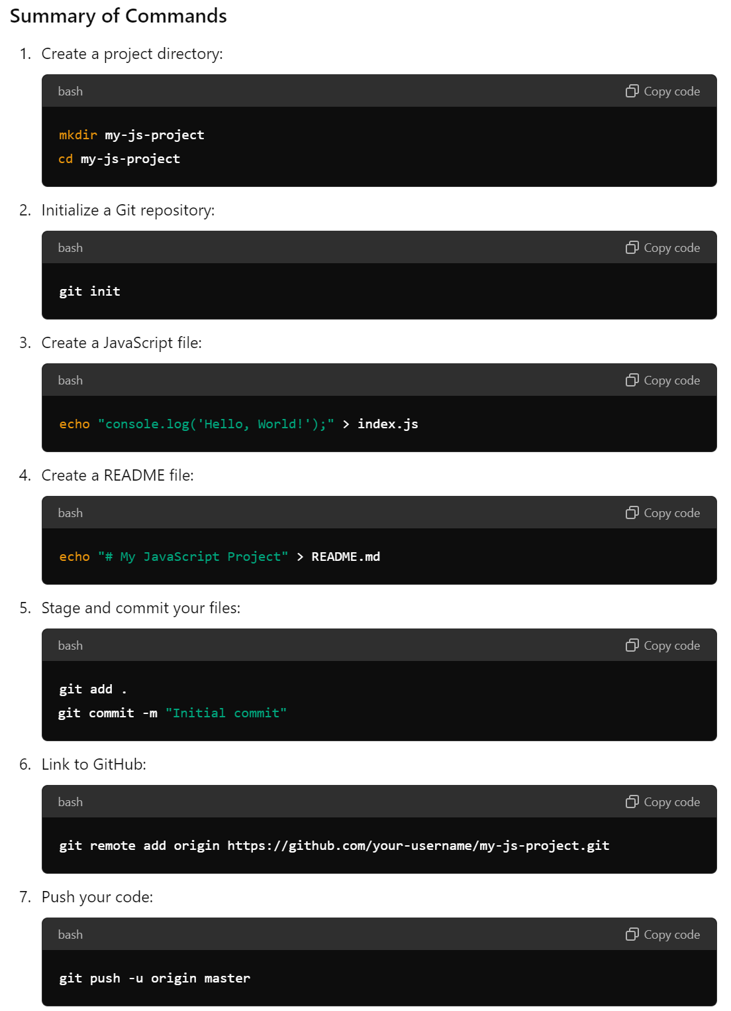

Instead of master we have to type **main**

I opened the folder in VS code and I used git status and I received this:  
 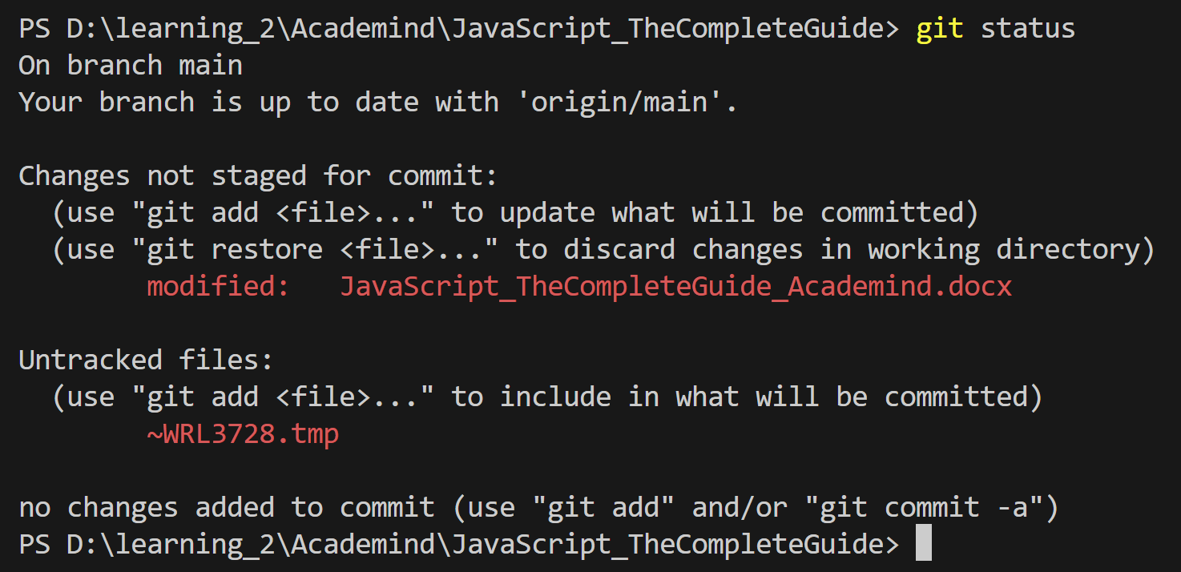

It tells us where I have made changes. It tells I have made changes in .docx and in a temporary files (~WRL3728.tmp) if I want to ignore temporary files or files that are not part of my project (like word temporary files) I can add them to a .gitignore like:  
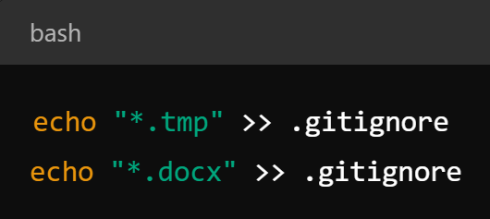

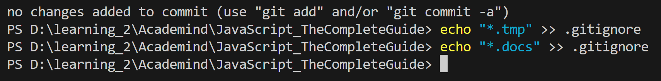

Now add the .gitignore file to our repository: we type git add .gitignore



Commit:  
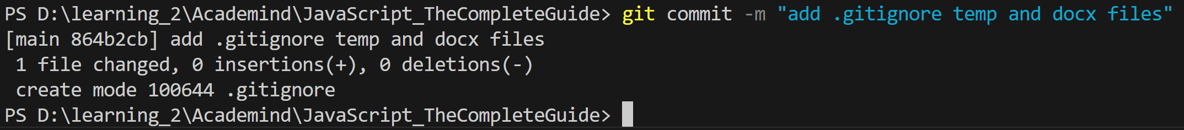

Now stage files we want commit (all or specific):  
type: git add .



Commit:

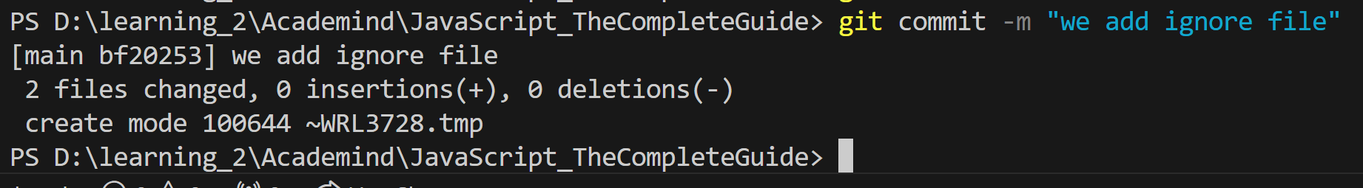

Push the changes to GitHub:  
type: git push origin main

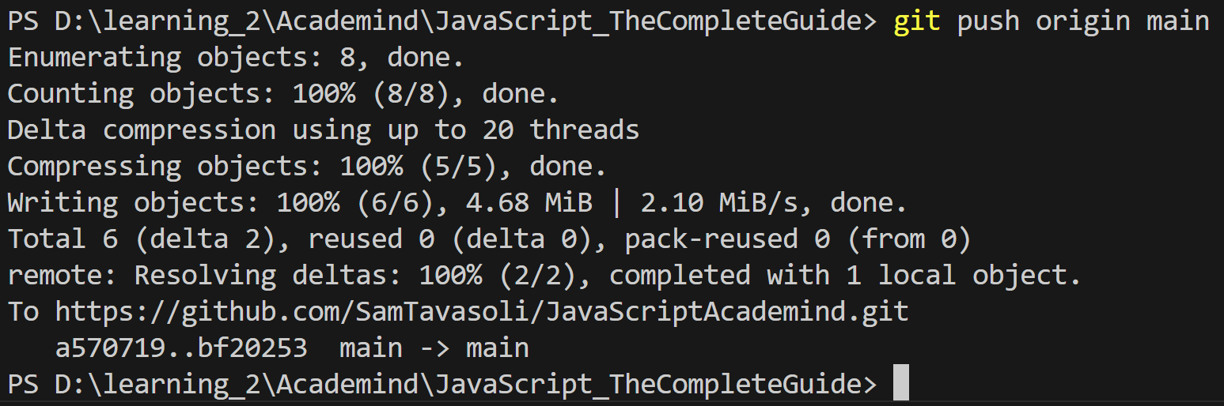

I put the docx in .gitignore file, but when I use git status, it still tell me :  
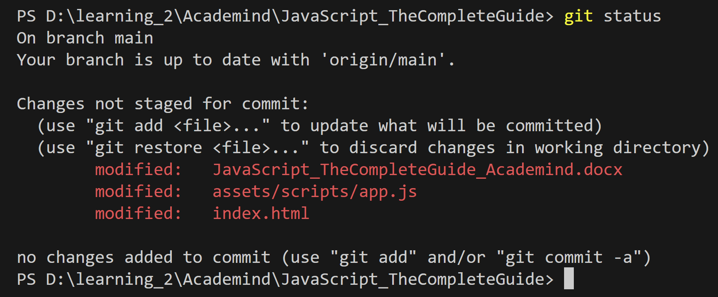

The solution is:  
The issue you’re encountering happens because the .docx file was already being tracked by Git before you added it to your .gitignore file. Once a file is tracked by Git, it will continue to be tracked even if you add it to .gitignore.

**How to Stop Tracking the .docx File**

To stop tracking the .docx file and any other files you want to ignore, follow these steps:

1. **Remove the .docx file from Git tracking without deleting it from your working directory**:

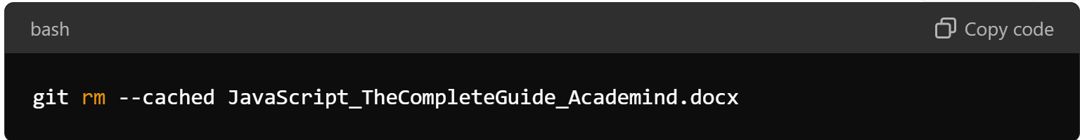

This command removes the file from the staging area (and stops Git from tracking it), but it keeps the file in your working directory.

1. **Add and commit the change**:

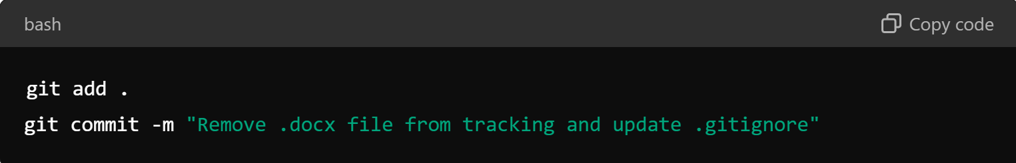

1. **Verify that Git is no longer tracking the file**:

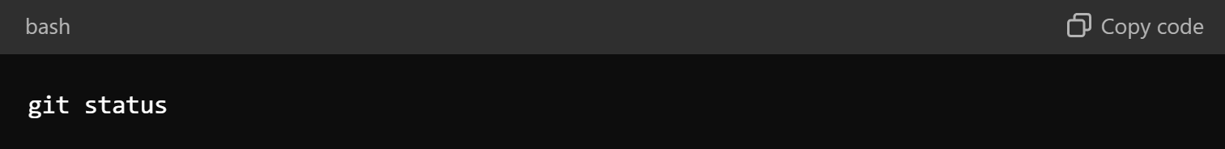

I did it :  


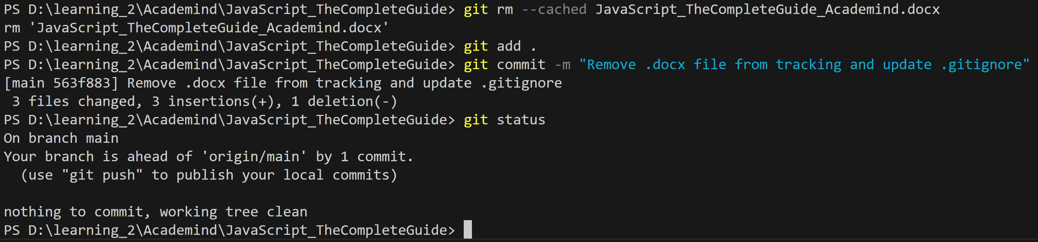

|  |
| --- |
| End of I m p o r t a n t ! |

Importing JavaScript to our index.html file:

We add it in the <head></head> section 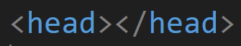

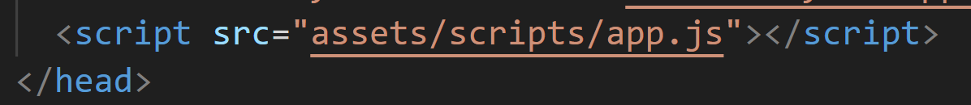

We can put on lower part, before the </body>

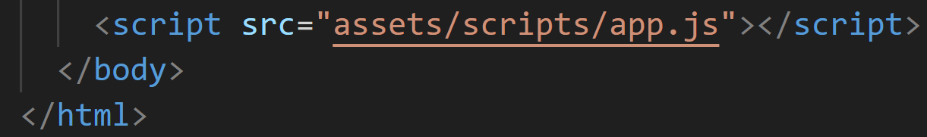



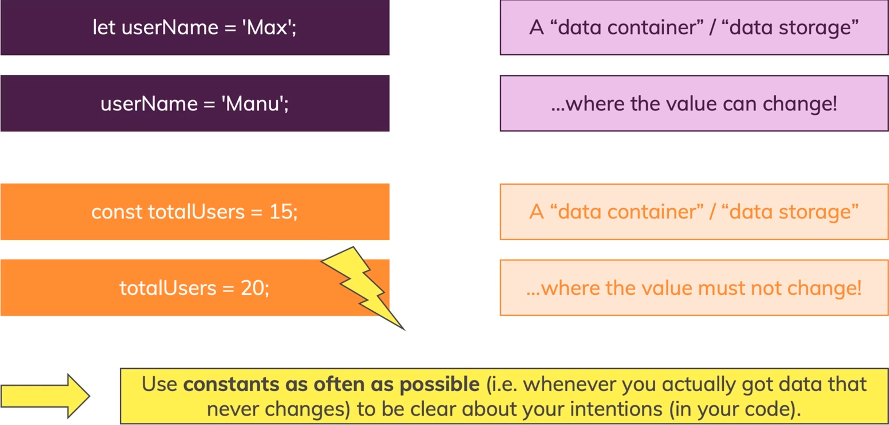

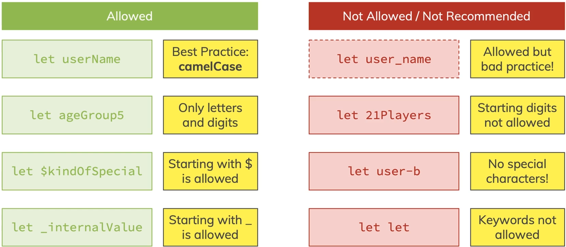

We can delete the semi-colon, but 🡺



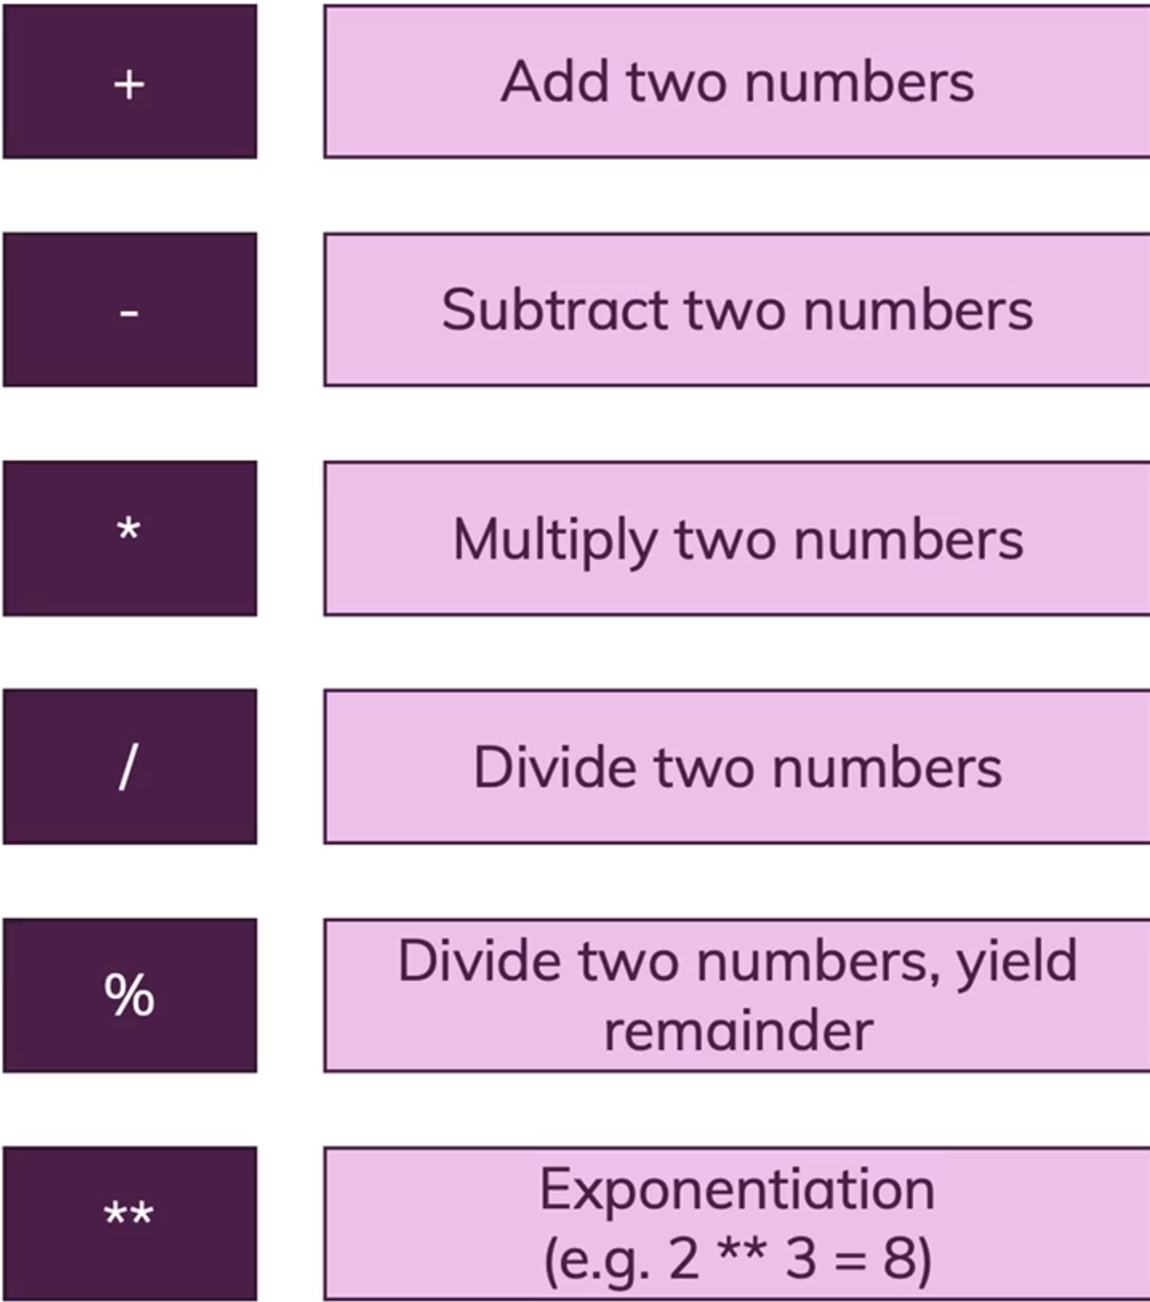

With backtick ` ` sign and ${} we can have the variables inside of the strings.



We say that the string contains a dynamic value.

We call it template literal.



